**2018 LIVESTOCK SHOW**



[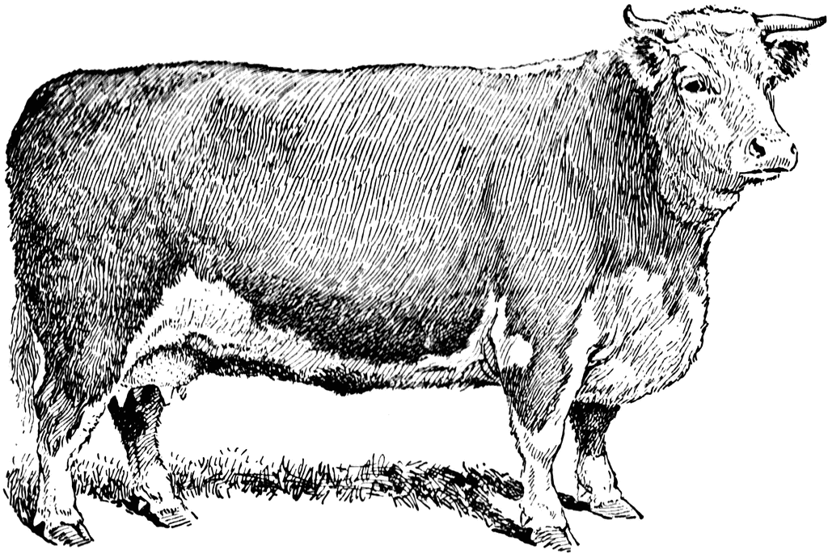](http://images.search.yahoo.com/r/_ylt=A0PDoS0uzdBPvjwAcc2jzbkF;_ylu=X3oDMTBpcGszamw0BHNlYwNmcC1pbWcEc2xrA2ltZw--/SIG=12cf62f7h/EXP=1339112878/**http:/etc.usf.edu/clipart/12000/12092/beefcow_12092.htm)



C:\Documents and Settings\Kim Gibson\Local Settings\Temporary Internet Files\Content.IE5\VSSJOQ08\MC900297217[1].wmf

ANSON IS ONLY HAVING A HEIFER AND LAMB SHOW THIS YEAR. NO GOATS



2018 Anson County

|  |  |  |
| --- | --- | --- |
| Parents Names:________________________________________ Parents email_______________________________________ | | |
| Address:___________________________________________ | | Phone:_______________________ Cell # ________________ |
| City: _________________ | Zip: _____________ | County: ____________________ |
|  |  |  |

**CHILD 1**

|  |  |
| --- | --- |
| Child’s Name___________Child’s Cell #__________Child’s Email____________Birthdate_______Age (As of Jan. 1, 2018):_____ |  |
| Circle Showmanship Division: Senior (14-19) Intermediate (11-13) Junior (9-10) Cloverbud (5-8) PeeWee (under 5) | |

|  |  |  |  |  |  |
| --- | --- | --- | --- | --- | --- |
| **Name of Animal** | **Birthdate of Heifer** | **Age** | **Scrapie Tag Breed**  **or Ear Tag** | | **Type of Animal**  **Lamb or Heifer** |
|  |  |  |  |  |  |
|  |  |  |  |  |  |
|  |  |  |  |  |  |
|  |  |  |  |  |  |
|  |  |  |  |  |  |
|  |  |  |  |  |  |

**CHILD 2**

|  |  |
| --- | --- |
| Child’s Name___________Child’s Cell #__________Child’s Email____________Birthdate_______Age (As of Jan. 1, 2018):_____ |  |
| Circle Showmanship Division: Senior (14-19) Intermediate (11-13) Junior (9-10) Cloverbud (5-8) PeeWee (under 5) | |

|  |  |  |  |  |  |
| --- | --- | --- | --- | --- | --- |
| **Name of Animal** | **Birthdate of Heifer** | **Age** | **Scrapie Tag Breed**  **or Ear Tag** | | **Type of Animal**  **Lamb or Heifer** |
|  |  |  |  |  |  |
|  |  |  |  |  |  |
|  |  |  |  |  |  |
|  |  |  |  |  |  |
|  |  |  |  |  |  |
|  |  |  |  |  |  |

**CHILD 3**

|  |  |
| --- | --- |
| Child’s Name___________Child’s Cell #__________Child’s Email____________Birthdate_______Age (As of Jan. 1, 2018): ____ |  |
| Circle Showmanship Division: Senior (14-19) Intermediate (11-13) Junior (9-10) Cloverbud (5-8) PeeWee (under 5) | |

|  |  |  |  |  |  |
| --- | --- | --- | --- | --- | --- |
| **Name of Animal** | **Birthdate of Heifer** | **Age** | **Scrapie Tag Breed**  **or Ear Tag** | | **Type of Animal**  **Lamb or Heifer** |
|  |  |  |  |  |  |
|  |  |  |  |  |  |
|  |  |  |  |  |  |
|  |  |  |  |  |  |
|  |  |  |  |  |  |
|  |  |  |  |  |  |

**CHILD 4**

|  |  |
| --- | --- |
| Child’s Name___________Child’s Cell #__________Child’s Email____________Birthdate_______Age (As of Jan. 1, 2018):_____ |  |
| Circle Showmanship Division: Senior (14-19) Intermediate (11-13) Junior (9-10) Cloverbud (5-8) PeeWee (under 5) | |

|  |  |  |  |  |  |
| --- | --- | --- | --- | --- | --- |
| **Name of Animal** | **Birthdate of Heifer** | **Age** | **Scrapie Tag Breed**  **or Ear Tag** | | **Type of Animal**  **Lamb or Heifer** |
|  |  |  |  |  |  |
|  |  |  |  |  |  |
|  |  |  |  |  |  |
|  |  |  |  |  |  |
|  |  |  |  |  |  |
|  |  |  |  |  |  |