Anson County
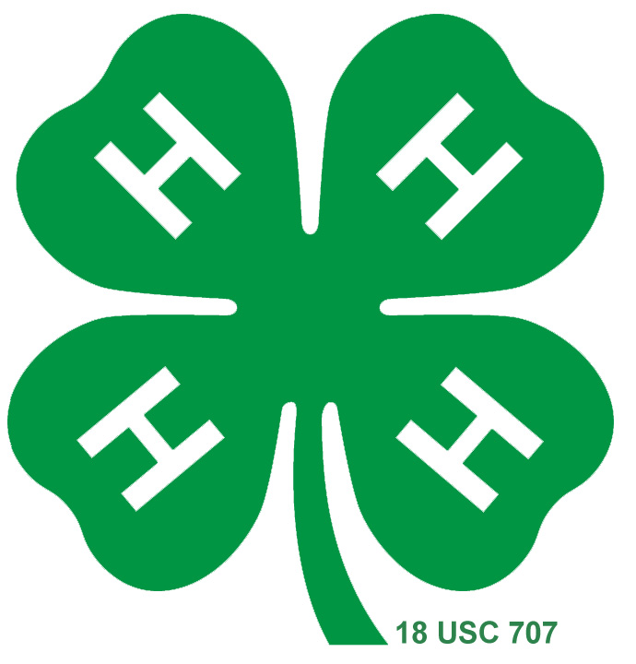
2018 4-H Livestock Show Rules

The Anson County Livestock Show will be held Saturday, September 22nd, 2018 at the
Circle G Arena in Lilesville, NC.

ANSON COUNTY WILL NOT HAVE A GOAT SHOW THIS YEAR, NOTE CHANGE IN PREMIUMS

- The show is open to all youth (5-19) that have not reached their 19th birthday prior to January 1st, 2018. All youth under the age of 9 (Cloverbuds) must be 5 years old by January 1, 2018, will not be judged under competition, but will exhibit non-competitively and receive participation ribbons and premiums. If another showman, older than Cloverbud is willing to show the animal competitively please let the show officials know the name of that person as soon as possible.

- All animals must have an official health certificate signed by an accredited veterinarian or approved state or federally employed veterinarian must accompany all lambs, heifers and goats. All goats and lambs must have USDA Scrapie tags in place before arrival on fairgrounds. Those animals that do not have a Scrapie tag will be asked to leave the show grounds. Sick and/or thin animals will not be accepted and will be at the discretion of show officials.

- Registration deadline is September 7th, 2018.

- Exhibitors are limited to 2 lambs, and/or 2 beef heifers. The animals must be under the exhibitor’s care. If an exhibitor has more than 1 animal in the same class, another exhibitor can show the additional animal after notifying show officials.

- Show officials reserve the right to arrange classes as needed.

- Exhibitors will automatically be entered into their showmanship classes.

- No wash facilities and electrical hookups are available, it is recommended that you wash and dry animals at home. No pens are available, but a make-up area is. Please bring lead ropes to tie animals. Limited drinks and snacks on site.

Saturday, September 22nd
Heifer Check –In 8:30 – 9:45 am
Heifer Show 10:00 am
Lamb Weigh-In 8:30 – 10:30 am
Lamb Show Following Heifers ~Approximately 12:00-1:00pm

Anson County Jr. Beef Heifer Show

- Heifers must be born between September 1, 2016 - April 30, 2018.
- Heifers must be halter broken. Unruly animals, which potentially endanger the safety of exhibitors or officials, will be asked to leave the ring.
- Heifers will be divided into classes by birthdate. Classes with more than 10 entries will be split. All breeds will be shown in one class according to date of birth.
- Limit two (2) beef heifers per youth.
- Grand Champion and Reserve Grand Champion will be presented rosette ribbons. Grand Champion Heifer- $100, Reserve Champion- $75. Junior, Intermediate and Senior Showmanship Champions will be presented chairs.
- All Cloverbud showmanship participants will receive $10.
Ages:
March & April 2018 May & June 2017
January & February 2018 March & April 2017
November & December 2017 January & February 2017
September & October 2017 November & December 2016
July & August 2017 September & October 2016

Anson County Market Lamb Show

- Open to ewe or wether lambs (no rams) weighing at least 75 lbs. All lambs must have baby teeth in place at the time of the show.
- Limit two (2) lambs per youth.
- Must have an official Scrapie tag in place.
- Lambs must be sheared and clean.
- Lamb classes will be divided by lamb weight. Show officials reserve the right to rearrange classes other than those advertised prior to show time.
- Showmanship classes will be divided into Junior (9-10), Intermediate (11-13), and Senior (14-19). Showmanship class entries will be determined by exhibitor age as of January 1, 2018.
- Showmanship classes will be based solely on showmanship – not fitting.
- All Cloverbud showmanship participants will receive $10.
- Grand Champion and Reserve Grand Champion will be presented rosette ribbons. Grand Champion Market Lamb- $50, Reserve Champion, $35. Junior, Intermediate and Senior Showmanship Champions will be presented chairs.

Entry Forms must be returned by September 7th, 2018 to:
Pictures of registration forms will not be accepted!
Hard copies, fax, and .pdf or .doc email only.
Roshunda Terry
Anson County Cooperative Extension
PO Box 633
Wadesboro, NC 28170
Fax #: 704.694.2248
Roshunda_terry@ncsu.edu

Lamb Classes will be paid on the following premium schedule:
Head | 1st | 2nd | 3rd | 4th | 5th
1 | 18
2 | 20 | 18
3 | 22 | 20 | 18
4 | 24 | 22 | 20 | 18
5 | 26 | 24 | 22 | 20 | 18
Exhibitors after 5th place will receive $15 participation

Heifers will be paid on the following premium schedule:
Head | 1st | 2nd | 3rd | 4th | 5th
1 | 32
2 | 34 | 32
3 | 36 | 34 | 32
4 | 38 | 36 | 34 | 32
5 | 40 | 38 | 36 | 34 | 32
Exhibitors after 5th place will receive $25 participation.

Directions to Anson County Livestock Show
Circle G Arena
301 N. Cowan St
Lilesville, NC 28091

From the east (Rockingham): Travel west on U.S. 74 to Lilesville. Turn right at the flashing caution light onto Camden Street. At stop sign turn right onto Wall Street. At caution light make left onto N. Cowan Street. Cross railroad tracks to enter Arena area.

From the west (Monroe): Travel east on U.S. 74 to Lilesville. Turn left at the flashing caution light onto Camden Street. At stop sign turn right onto Wall Street. At caution light make left onto N. Cowan Street. Cross railroad tracks to enter Arena area.

From the north (Albemarle): Travel south on U.S. 52 to Wadesboro. At the intersection of U.S. 74, turn left to follow 74 East to Lilesville. Turn left at the flashing caution light onto Camden Street. At stop sign turn right onto Wall Street. At caution light make left onto N. Cowan Street. Cross railroad tracks to enter Arena area.

If you need additional information, please call the Extension Office at 704-694-2915.

